Programming VSDSquadron-Mini via OTA

BY

Vishnu Prakash Bharadwaj

**AIM:**

1. To program VSDSquadron-Mini using wireless mode of communication like WiFi, BLE, etc.
2. Basic OTA with Arduino IDE and Web Updater OTA

As VSDSquadron-Mini does not contain any modules/peripherals related to wireless communication, we can make use of an external module like WiFi: ESP-32 / NodeMCU.

**COMPONENTS:**

1. VSDSquadron-Mini
2. Espressif ESP32-WROOM-32UE WiFi Module
3. Some jumpers
4. Mini USB cables to power up the board.

**APPROACH:**

Using ESP-32 flashed with esp-link firmware and UART communication between VSDSquadron-Mini and Esp-32. (<https://github.com/jeelabs/esp-link>)

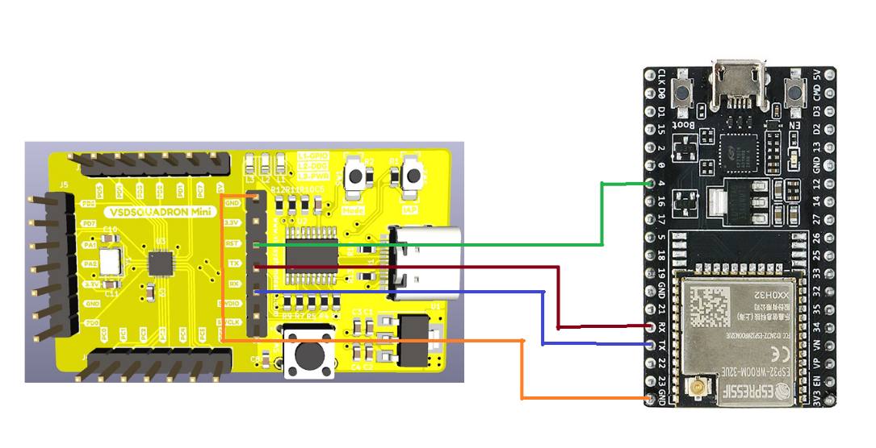

**NOTE:**

* Currently, VSDSquadron-Mini uses one-wire protocol to flash it with the firmware. The WCH-LinkE uses one-wire programming. We can overcome this problem, to support programming through UART as mentioned in the following link.
  + <https://pallavaggarwal.in/2023/11/22/ch32v003-how-to-flash-program-using-serial-port/>
* The esp-link tool only supports Arduino/AVR microcontrollers, LPC800-series and other ARM microcontrollers. There is need for bare-metal programming to create a custom bootloader, to include OTA features for the RISC-V microcontrollers. There is a need for a firmware update strategy in this limited flash space.